2025 Education Workshop Registration
____ July 24 Mt. Vernon (EVENING)
Mt. Vernon Outland Airport
100 Aviation Dr
Mt. Vernon, IL 62864
____ July 30 Mt. Sterling (EVENING)
KC Hall
Quincy Rd
Mt. Sterling, IL 62353
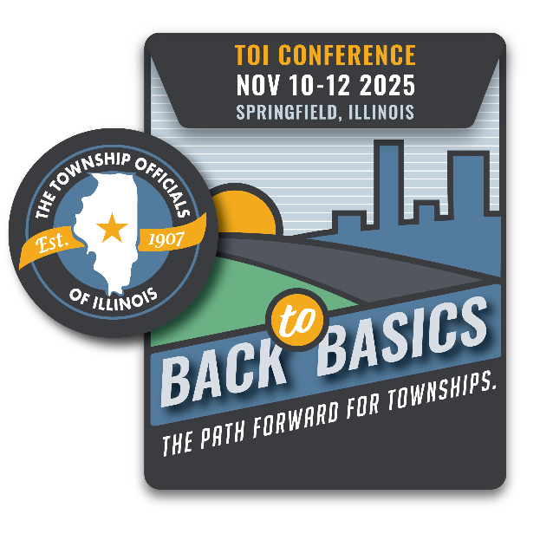
September 5 Peoria (DAY)
Holiday Inn
7601 N Orange Prairie Rd
Peoria, IL 61615
September 19 Rockford (DAY)
Tebala Event Center
7910 Newburg Rd
Rockford, IL 61108
October 3 Normal (DAY)
Normal Township Activity and Rec Center
600 E Willow St
Normal, IL 61761
County Township
Address
City State Zip
Names & Email of those who will attend (please print clearly):
Supervisor: Township Clerk: Highway Comm.: Assessor: Trustee: Trustee: Trustee: Trustee: Collector: Other/title:
Registration is $50 per location, per person or $300/township for up to eight attendees. On-site registration is $75 per person. No refunds will be given once TOI has confirmed attendance with venue.
*Please make checks payable to the Township Officials of Illinois; mail to 3217 Northfield Drive., Springfield, IL 62702. Forms may also be emailed to teresa@toi.org. If you are paying by credit card, only Visa and MasterCard are accepted:
Name, as it appears on card: Credit Card Number Exp.:

